Ricardo Eskenazi

Term Project

1, you must describe your database application.

This database application consists of movies database in which users can query movies by their title and look for their release date, budget, and revenue, also user have access to an actors and directors table where they can filter them by country or by what movies they have participated in, users can filter by different specific genres or by the studio that distributed the film and look what actors acted on which movies.

2, you must submit the conceptual and logical design of your database as specified in section **Design and Implementation**, which include the E-R diagram and relational database schema of your database. For each table:

E-R diagram: 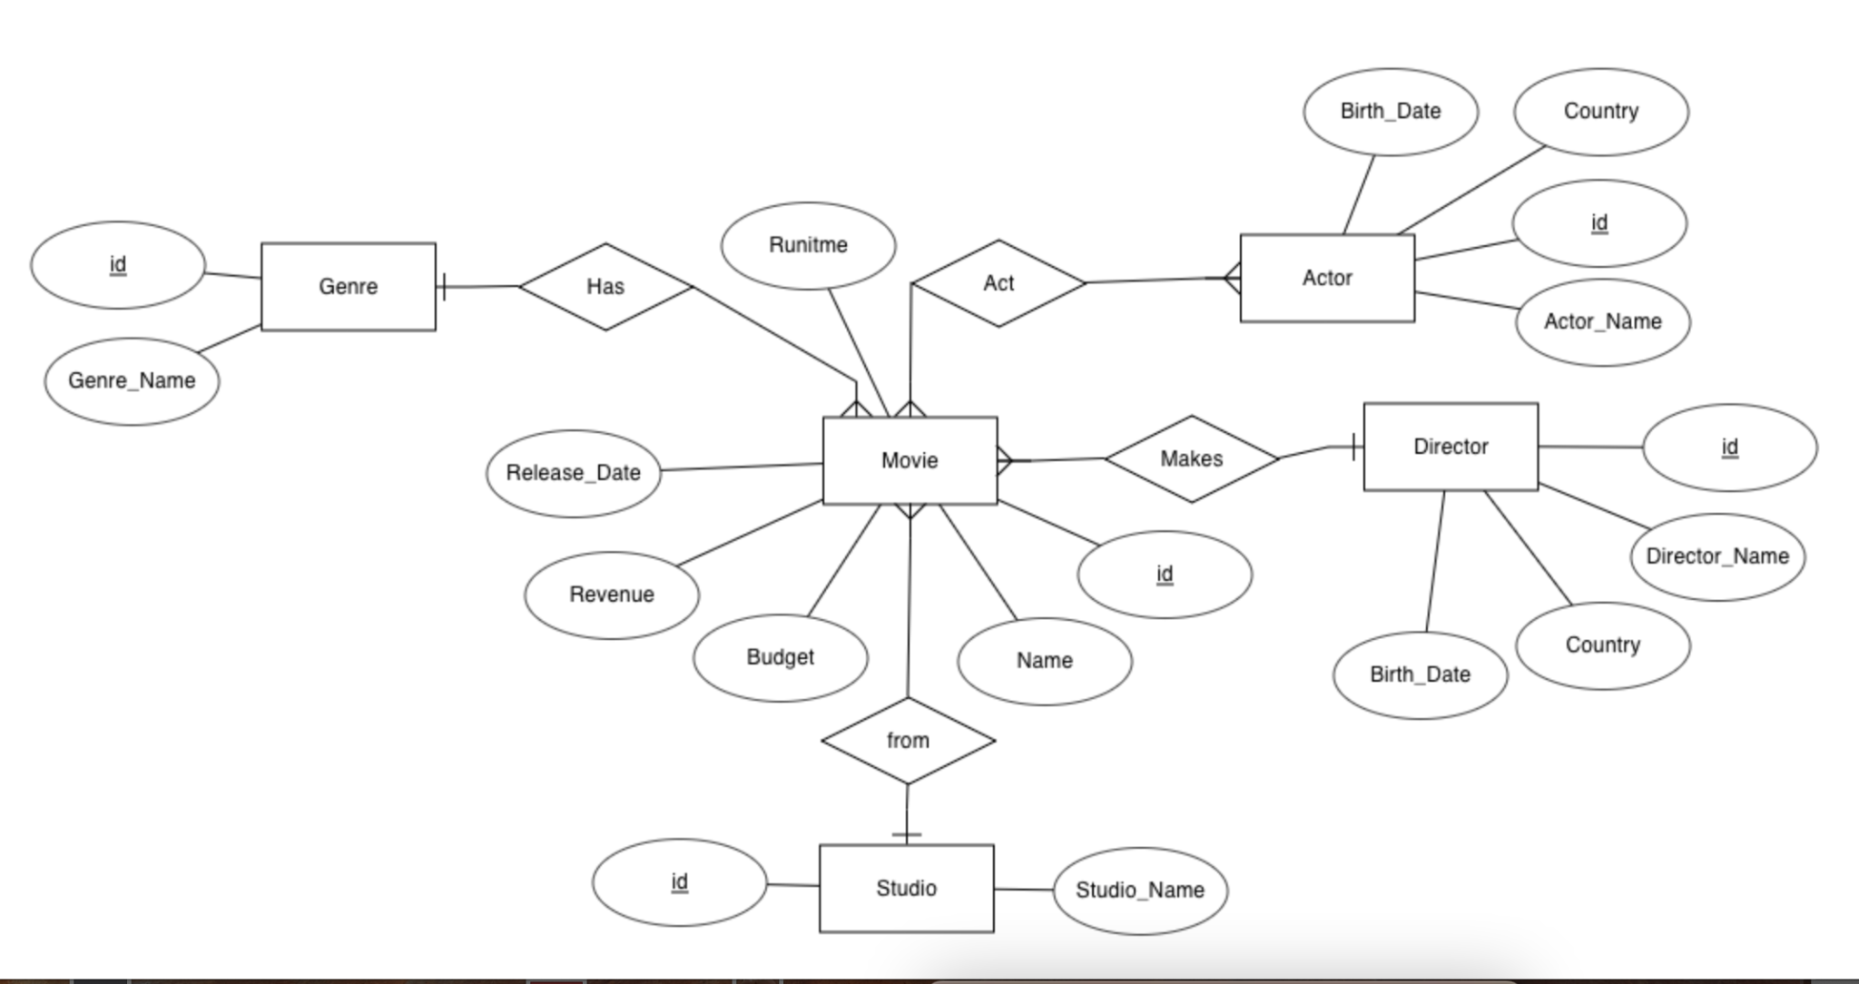

Relational database schema:

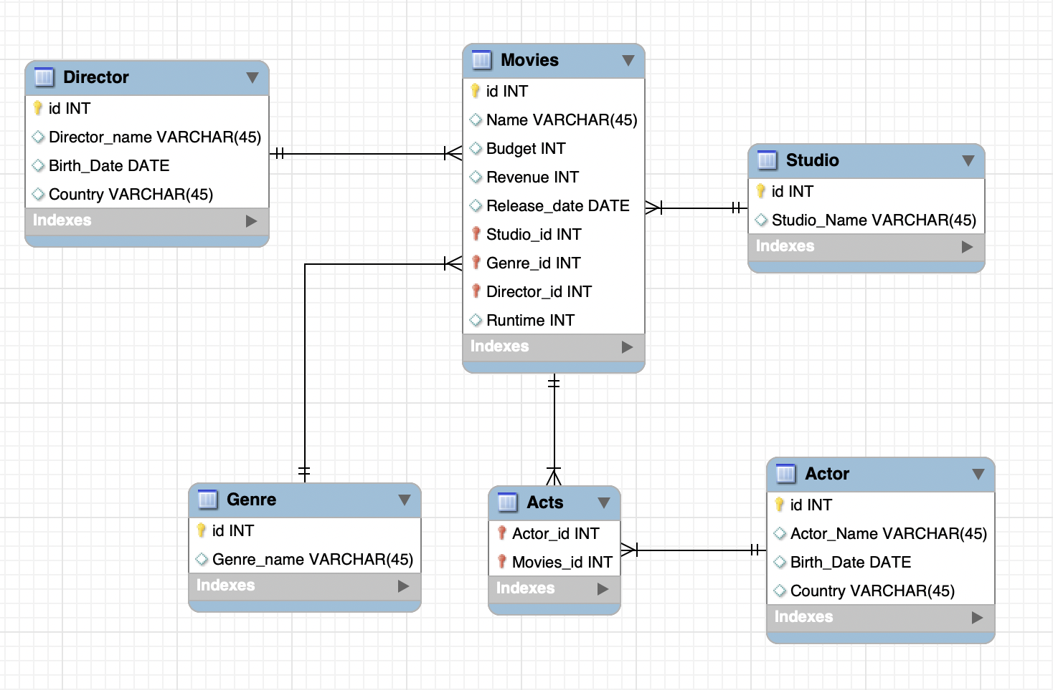

a, describe all the attributes (including attribute names, data types etc.);

**Director entity has four attributes:**

1- Attribute id is a primary key of the director; each one has a unique id that can identify the director record in the table.

2- Director_name has a data type of varchar with a maximum length of 45 characters to store the name of the director.

3- Birth_Date has a data type of date to store the year, month, and days value for the birth date of the director.

4- Country has a data type of varchar with a maximum length of 45 characters to store the country of the director.

**Movies entity has nine attributes:**

1. Attribute id is a primary key of the movies, each one has a unique id that can identify the movie record in the table.
2. Name has a data type of varchar with a maximum length of 45 characters to store the name of the movie.
3. Budget has a data type of int to store the budget value of the movie.
4. Revenue has a data type of int to store the revenue value of the movie.
5. Release date has a data type of date to store the release date of the movie.
6. Studio_id is a foreign key that refers to the primary key of the Studio table, it is used to link between the tables of Movies and Studios.
7. Genre_id is a foreign key that refers to the primary key of the Genre table, it is used to link between the tables of Movies and Genre.
8. Director_id is a foreign key that refers to the primary key of the Director table, it is used to link between the tables of movies and the Director.
9. Runtime has a data type of int to store the runtime value of the movie.

**Studio entity has two attributes:**

1. Attribute id is a primary key of the studio, each one has a unique id that can identify the studio record in the table.
2. Studio_name has a data type of varchar with a maximum length of 45 characters to store the name of the studio.

**Genre entity has two attributes:**

1. Attribute id is a primary key of the genre, each one has a unique id that can identify the genre record in the table.
2. Genre_name has a data type of varchar with a maximum length of 45 characters to store the name of the genre.

**Acts entity has two attributes:**

1. Actor_id is a foreign key that refers to the primary key of the Actor table, it is used to link between the tables of Acts and Actor.
2. Movies_id is a foreign key that refers to the primary key of the Movies table, it is used to link between the tables of Acts and Movies.

**Actor entity has four attributes:**

1. Attribute id is a primary key of the acts, each one has a unique id that can identify the acts recorded in the table.
2. Actor_name has a data type of varchar with a maximum length of 45 characters to store the name of the actor.
3. Birth_Date has a data type of date to store the year, month, and days value for the birth date of the actor.
4. Country has a data type of varchar with a maximum length of 45 characters to store the country of the actor.

b, specify the primary keys and foreign keys (if exist);

Primary keys:

* Movies: id
* Studio: id
* Actor: id
* Genre: id
* Director: id

Foreign keys:

* Movies: Studio_id, Genre_id, Director_id
* Acts: Actor_id, Movies_id

c, discuss which Normal Form it is in.

The relational database schema previously explained, is on the third normal form because to be on 3NF it needs to be on the first and second normal form first, the database is on the first normal form because there are no composite or multi valued attributes, the database is on the second normal form because none of the tables have partial dependencies and lastly it is in the third normal form because there are non-transitive dependencies.

d, provide the SQL DDL statement you used to create the table, or the screen snapshots if your used GUI.

Studio and Genre Table:

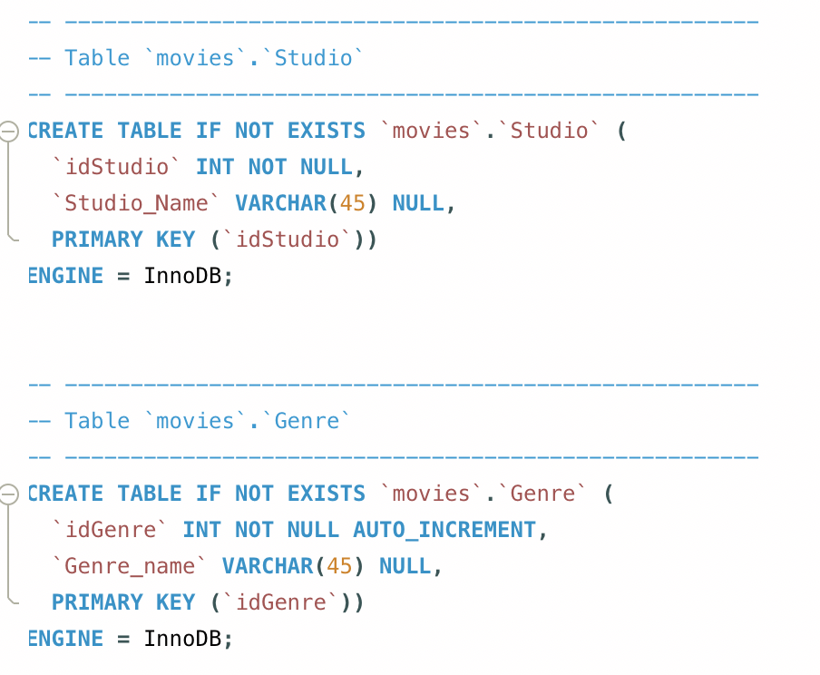

Actor Table:

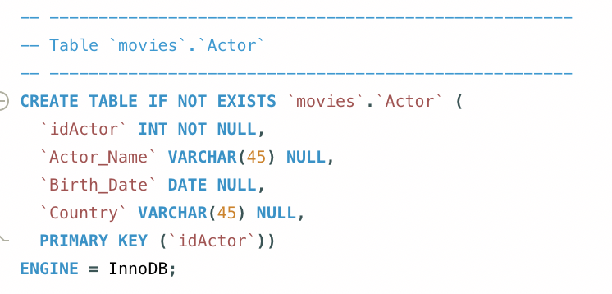

Movies Table:

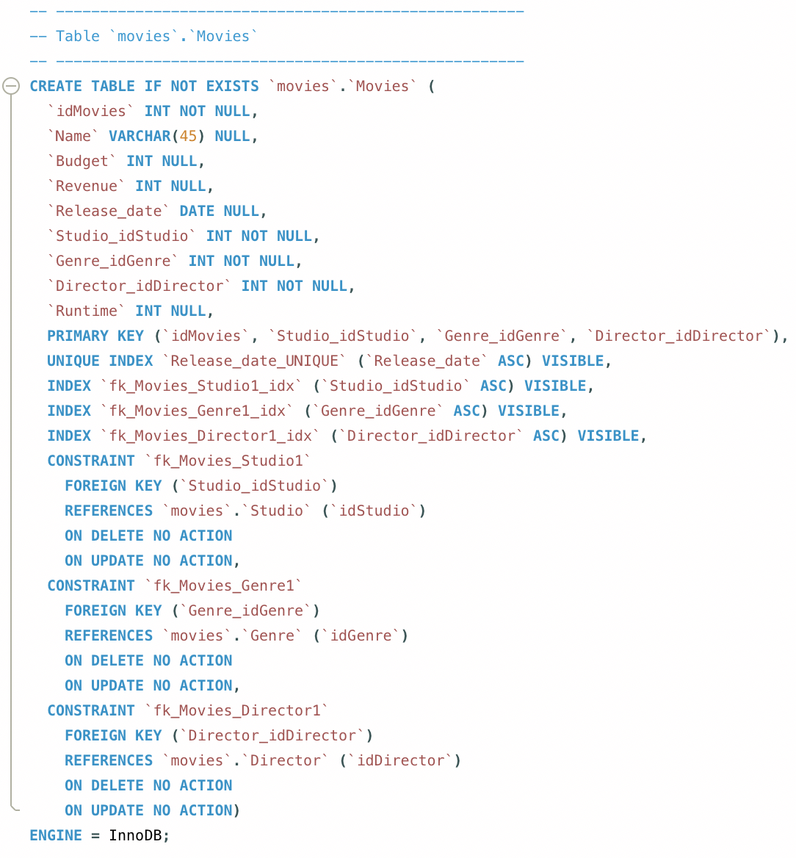

Director Table:

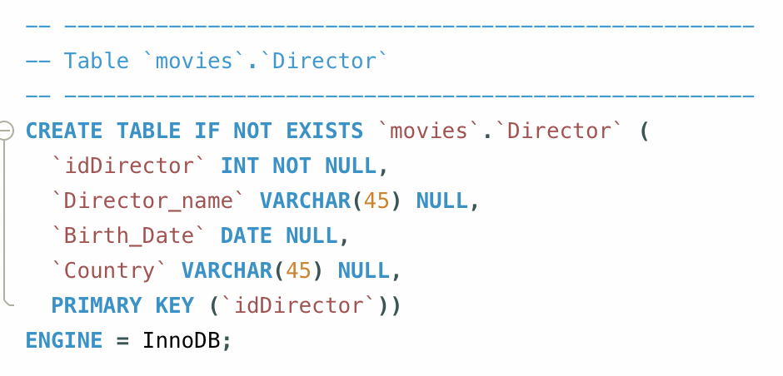

Acts Table:

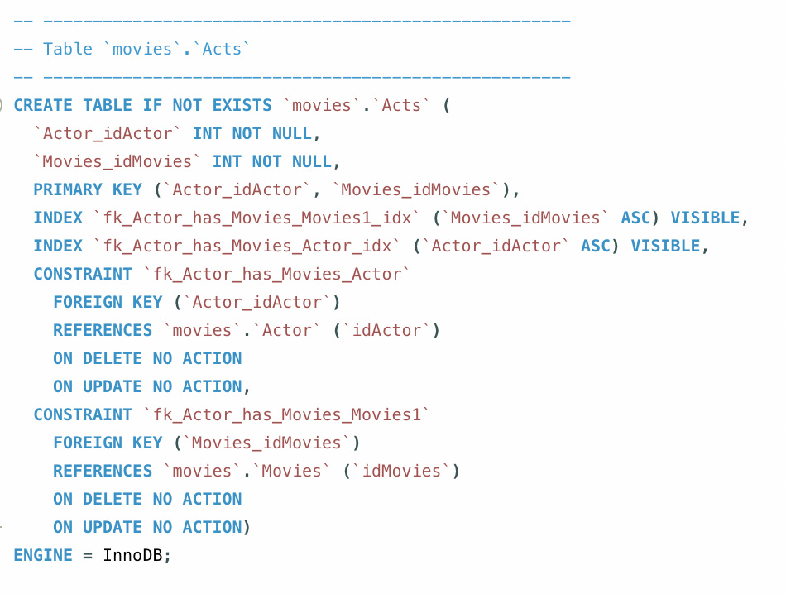

e, Output all the records in the table using “Select * from example_table;”

Movies Table:

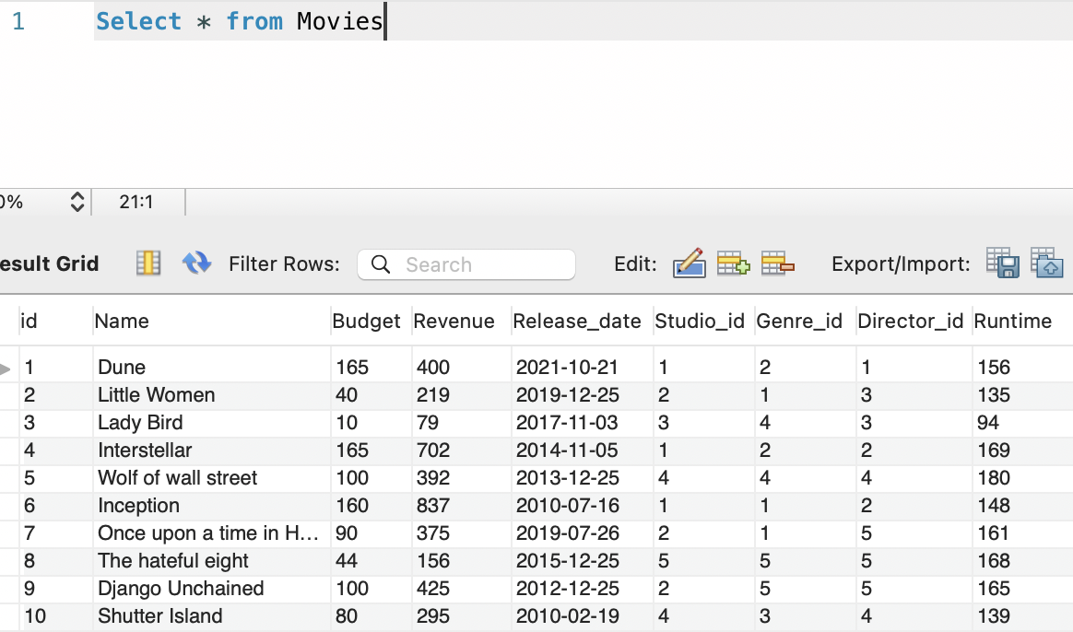

Genre Table: Director Table:

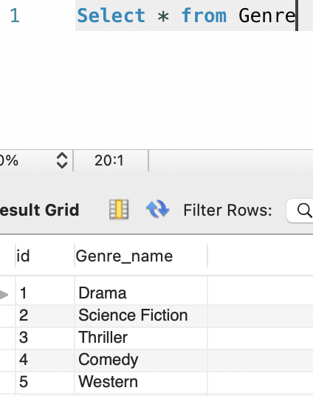 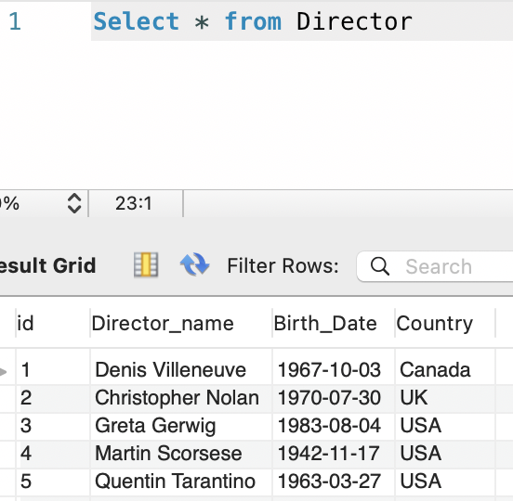

Studio Table:

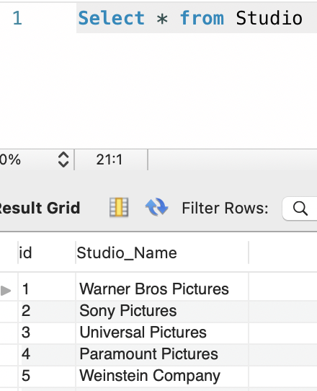

Actor Table:

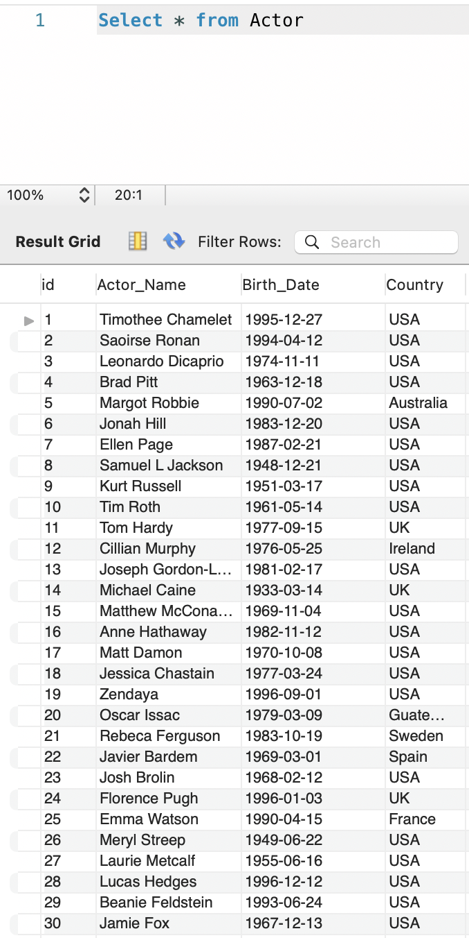

Acts Table:



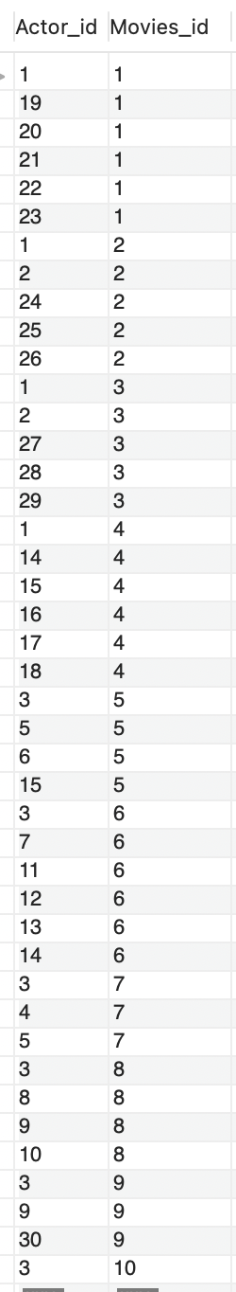

QUERIES

1. All of the movies of the genre science fiction that came out between 2013 and 2021

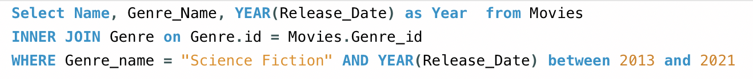

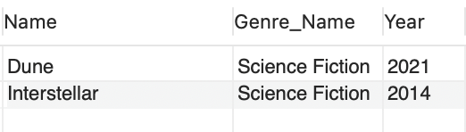

1. All of the movies that earned more than 300 million dollars after 2015, order the results in descendent way.

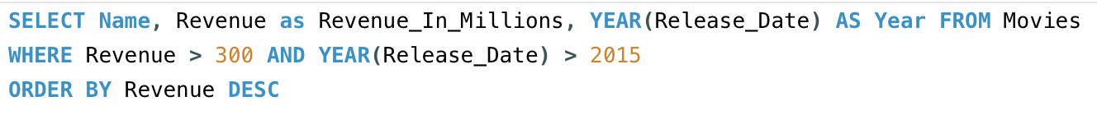

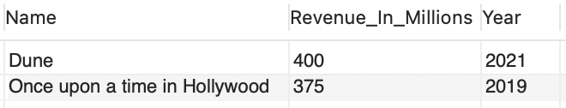

1. All of the movies directed by Quentin Tarantino where Leonardo DiCaprio also acts.

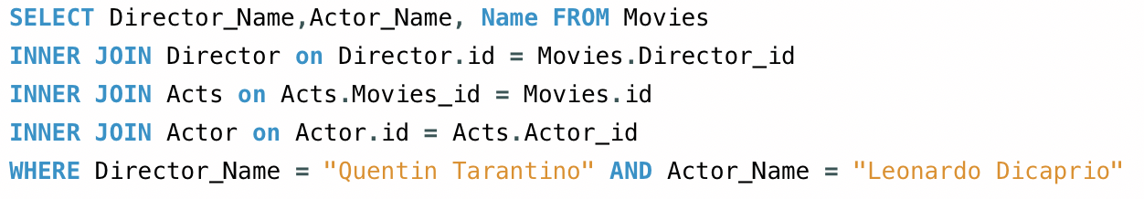

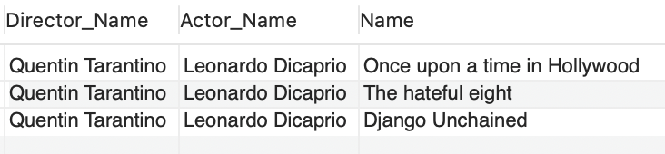

1. What is the average revenue that the studio warner bros pictures has earned from 2015 onwards

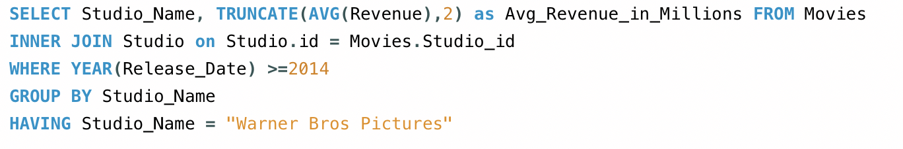

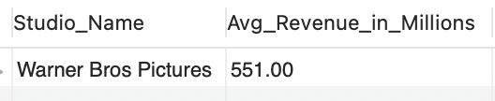

1. How many movies has Leonardo Dicaprio acted between 2010 and 2019?

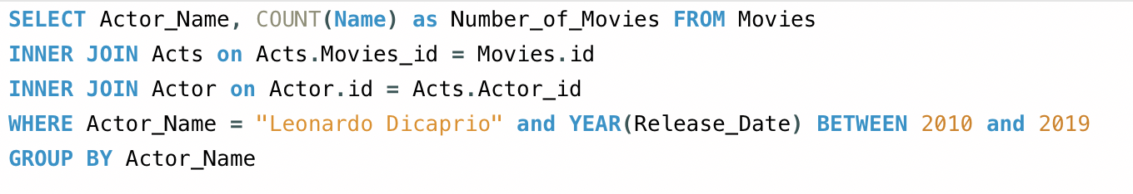

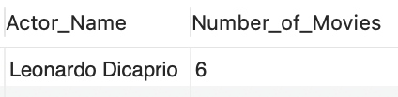

1. How many movies per genre have been released

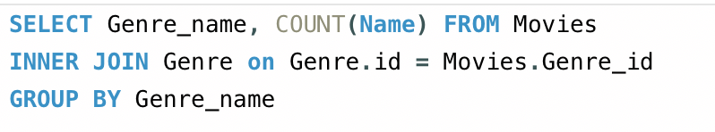

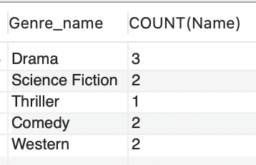

1. How many movies each director has made and the sum of the revenue of the movies of each director.

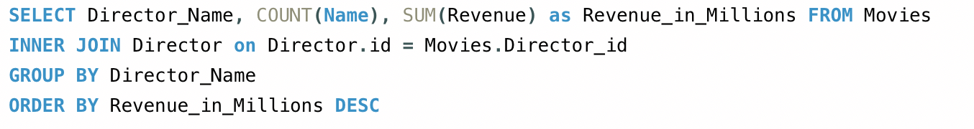

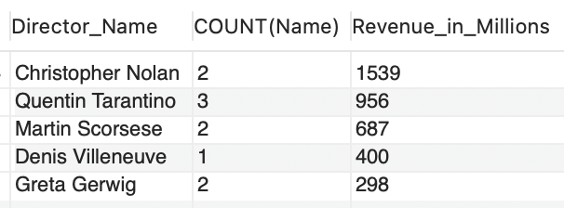

1. On what movie did matt damon acted that was of the genre science fiction and was directed by christopher nolan.

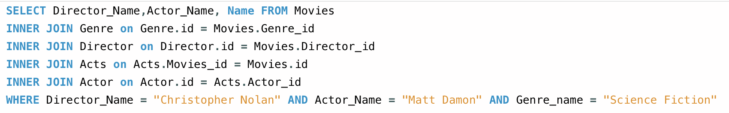

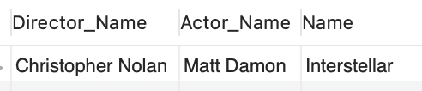

1. How many movies were distributed by the studio Sony pictures

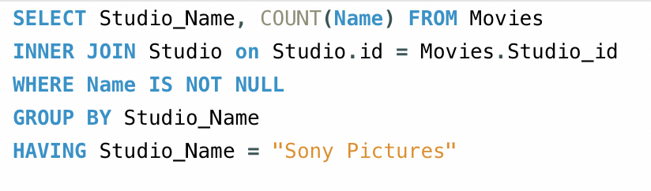

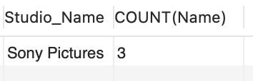

1. All the movies that had a revenue of more than 300 million.

